2014 U4 AOS 1-SOLUTIONS
2014 U4 AOS 1 Test

Question 1
Assuming that reactants and products are in a closed system, which of the following statements is not true when considering the chemical equilibrium of the following endothermic reaction?
CO (g) + 3 H₂ (g) ⇌ CH₄ (g) + H₂O (g)
A. | An increase in amount of CO will decrease the equilibrium amount of H₂ present.
B. | A decrease in the volume of gas mixture will decrease the equilibrium amount of H₂ present.
C. | An increase in temperature will decrease the equilibrium amount of CH₄ present.
D. | Removal of CH₄ from the reactor vessel will decrease the amount of H₂ when equilibrium is re-established.

Answer : C

Use the following information to answer Questions 4 and 5
4 NH₃ (g) + 5 O₂ (g) ⇌ 4 NO (g) + 6 H₂O (g) ΔH is negative

Question 4
The equilibrium expression for this reaction is:
A. | $$\frac{4\left[NO\right]6[H_{2}O]}{4\left[{NH}_{3}\right]{5[O}_{2}]}$$
B. | $$\frac{{[NO]}^{4}}{{[{NH}_{3}]}^{4}{[O_{2}]}^{5}}$$
C. | $$\frac{{[{NH}_{3}]}^{4}{[O_{2}]}^{5}}{{[NO]}^{4}{[H_{2}O]}^{6}}$$
D. | $$\frac{{[NO]}^{4}{[H_{2}O]}^{6}}{{[{NH}_{3}]}^{4}{[O_{2}]}^{5}}$$

Answer : D

Question 5
If the equilibrium constant, K_{eq} value for the forwards reaction is 34 M at 298 K, what would be the K_{eq} value for the reverse reaction at the same temperature?
A. | 34 M⁻¹
B. | 0.058 M
C. | 0.029 M⁻¹
D. | - 34 M

Answer : C

Question 6
Water undergoes self-ionisation via an endothermic reaction. If a 100 mL sample of water was heated over a Bunsen burner for 10 minutes
A. | The pH would decrease and the water would become more acidic.
B. | Both the pH and the K_{w} values would decrease and the water would become more acidic.
C. | The pH would decrease, the K_{w} value would increase and the water would remain neutral.
D. | Both the pH and the K_{w} values would increase and the water would remain neutral.

Answer : C

Question 8
When an exothermic reaction takes place, the reaction mixture gets hotter because
A. | in an exothermic reaction the products are less stable than the reactants.
B. | energy is always absorbed in a chemical change which makes a new substance.
C. | more energy is released when new product bonds are made than is needed to break reactant bonds.
D. | exothermic changes always produce gases.

Answer : C

Question 9
Which of the following chemical equations is used in the final stage of the Contact process for producing sulfuric acid?
A. | SO₃ (g) + H₂SO₄ (l) H₂S₂O₇ (l)
B. | SO₃ (g) + H₂O (l) H₂SO₄ (aq)
C. | 4 KNO₃ (s) + 4 SO₂ (g) + 4 H₂O (l) 2 K₂O (s) + O₂ (g) + 4 NO (g) + 4 H₂SO₄ (aq)
D. | SO₂ (g) + H₂O₂ (aq) H₂SO₄ (aq)

Answer : A

Use the following information to answer Questions 10 and 11
Six experiments were set up as shown in Table 1 in which specific amounts marble chips (calcium carbonate) were added to hydrochloric acid. The volume of carbon dioxide produced was measured over the same period of time for each experiment, and in each experiment the marble chips were completely dissociated according to the reaction:
CaCO₃ (s) + 2HCl (aq) CaCl₂ (aq) + H₂O (l) + CO₂ (g)
Table 1: Experiment conditions
Experiment | HCl volume (mL) | HCl concentration (M) | CaCO₃ chips mass (g) | Temperature (°C)
1 | 100 | 1.0 | 1.0 | 20
2 | 100 | 1.0 | 2.0 | 20
3 | 200 | 1.0 | 1.0 | 20
4 | 100 | 2.0 | 1.0 | 20
5 | 100 | 1.0 | 1.0 | 30
6 | 100 | 2.0 | 2.0 | 20

Graph A below represents results taken from Experiment 1.
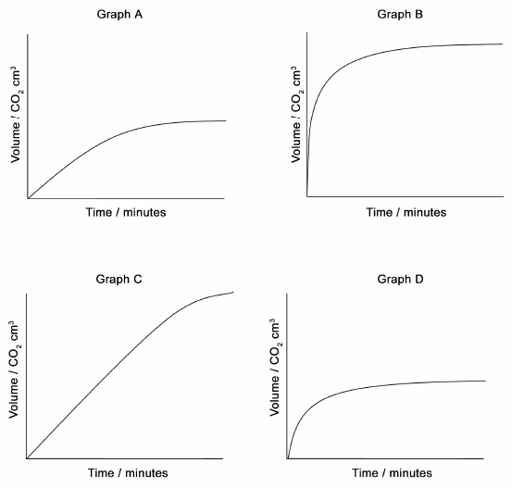
Volume / CO₂ mL
Volume / CO₂ mL
Volume / CO₂ mL
Volume / CO₂ mL

Question 10
Which of the graphs show the fastest rate of reaction?
A. | Graph A
B. | Graph B
C. | Graph C
D. | Graph D

Answer : B

Question 11
Graph D represents results from two of the experiments. These experiments were:
A. | Experiment 2 and Experiment 3
B. | Experiment 5 and Experiment 6
C. | Experiment 2 and Experiment 6
D. | Experiment 4 and Experiment 5

Answer : D

Question 12
A mixture of 1.05 mol of N₂ and 1.20 mol of H₂ are placed in a 3.0 L container and the following reaction occurs:
N₂ (g) + 3 H₂ (g) ⇌ 2 NH₃ (g)
When the reaction reaches equilibrium, [H₂] = 0.100 M. What is the value of [N₂] and [NH₃] respectively?
A. | 0.0500 M and 0.0300 M
B. | 0.250 M and 0.200 M
C. | 0.0333 M and 0.0667 M
D. | 0.650 M and 0.300 M

Answer : B

Question 13
The pH of a 0.420 M hydrocyanic acid, HCN, solution at 25°C is:
A. | 4.79
B. | 1.35
C. | 9.57
D. | 5.79

Answer : A

Question 3 (8 marks)
Consider the following reaction:
H₂ (g) + F₂ (g) 2 HF (g)
Energy required to break bonds 594 kJ
Energy released when making new bonds 1130 kJ
- Is the reaction exothermic or endothermic? Explain your answer.
More energy is released when making bonds to form new products than when breaking bonds within reactants. 1 mark
As the excess energy is released, this reaction is exothermic. 1 mark
2 marks

- Use the axis provided to construct an energy profile diagram for the reaction given above. Your diagram does not need to be drawn to scale but must include:
  - Labels and values for each axis Energy (kJ) or (kJ/mol), Time (min) not necessary but no penalty if present. 1 mark
  - Formulas of reactants and products Reactants (left) higher than products (right) 1 mark
  - Enthalpy change of the reaction, ΔH and its value Correct line drawn and value given -563 kJ or kJ/mol1 mark
  - Activation energy and its value Correct line drawn and value given 594 kJ or kJ/mol 1 mark

1 + 1 + 1 + 1 = 4 marks
- Explain how the use of a catalyst would affect the reaction. Show this in the diagram in (b) above.
New pathway drawn on the diagram above 1 mark
The catalyst lowers the activation energy which subsequently increases the rate of reaction OR 1 viable point about how the activation energy is lowered. e.g. providing an alternative pathway 1 mark

Question 4 (6 marks)
Two identical reaction vessels (System 1 and System 2) are set up under the same conditions and are allowed to reach equilibrium according to the equation: N₂O₄ (g) ⇌ 2 NO₂ (g)
Each vessel is kept at a constant temperature of 80°C. The equilibrium concentration of the gases in each vessel are: [N₂O₄] = 3.0 M, [NO₂] = 1.0 M. At 2 minutes the following changes were made:
System | Change applied at Time = 2 minutes | Observation
1 | More NO₂ is injected into the container | 30 seconds later the system reached equilibrium
2 | The volume of the container was suddenly decreased | 30 seconds later the system reached equilibrium

- Using the axis provided below sketch a graph which shows the concentration changes within System 1 over 3 minutes time.
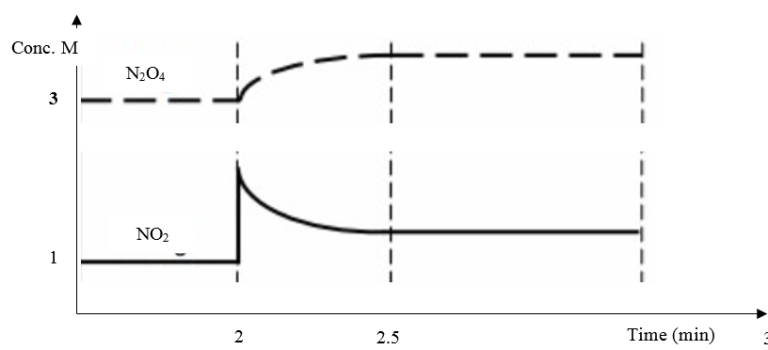
Labelled axis (no penalty for lack of units) 1 mark
Initial equilibrium concentrations correct 1 mark
Change and final equilibrium concentrations correct 1 mark
3 marks

- Describe one main difference that would be observed if a graph was drawn to show the concentration changes within System 2 over 3 minutes time.
Both concentrations would spike at 2 min (must specify both concentrations and time)
1 mark

- At 2 minutes and 10 seconds [NO₂] in System 2 = 1.46 M and the reaction quotient is 0.573 M at 80°C. Use this information to calculate the concentration of N₂O₄ at this time.

0.573 M = [NO₂]² / [N₂O₄] 1 mark for expression (due to units - forwards reaction)
0.573 M = 1.46² / [N₂O₄]

[N₂O₄] = 1.46² / 0.573 = 3.72 M (no units required) 1 mark

Note: Award 1 mark only of reverse reaction is used

2 marks

Question 6 (4 marks)

5.00 mol of propanoic acid was added to water to make up a 1.0 L solution that was kept at a constant temperature of 25°C. At equilibrium, 0.22% of the acid had ionised to form C₂H₅COO⁻ ions. Calculate the pH of the solution at equilibrium.
[C₂H₅COOH] = 5.00M 0.22% of 5.00 = 0.011M 1 mark
[C₂H₅COO—] = [H⁺] = 0.011 M 1 mark
pH = -log(0.011) = 1.958 1 mark
= 2.0 1 mark (2 sig fig)

